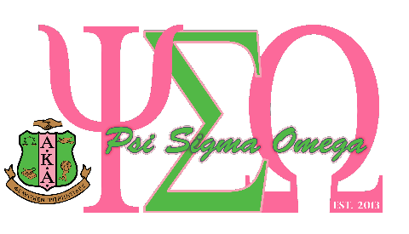

ALPHA KAPPA ALPHA SORORITY INCORPORATED® PSI SIGMA OMEGA CHAPTER

ALFREDIA WRIGHT MURPHY SCHOLARSHIP REQUIREMENTS AND APPLICATION CHECKLIST

The Alpha Kappa Alpha Sorority Inc., Psi Sigma Omega Chapter is honored to award $500 scholarships to graduating seniors attending school in Garner or Johnston County. Scholarships are awarded to students who maintain a 2.5 GPA on a 4.0 scale, pursuing higher education and present a financial need to pursue their academic goals.

Scholarship Requirements:
- Full-time student
- Graduating senior attending school in Garner or Johnston County
- Minimum 2.5 GPA on a 4.0 scale
- Acceptance to an accredited college, junior college, university or technical school
- Demonstrates community service and involvement

Application Checklist
Please read all instructions carefully before completing an application form. Only completed applications post-marked by April 30, 2020 will be considered. Completed applications must include the following seven (7) items. Please use the checklist below to ensure your application is complete.

- A completed application form
- An official high school transcript
- A letter of acceptance from a college, junior college, university or technical school
- Two (2) letters of recommendation
- A copy of SAT/ACT report
- Recent photo or senior portrait
- An essay of 500 words, typed, grammatically correct, neat and a clear expression of ideas. Your essay should address how social media (i.e. Facebook, Twitter, Snapchat, Instagram and etc.), if used correctly, will support your journey to attain higher education, employment and ultimately your career goals. Your essay should also address how, if used incorrectly, social media can present barriers to your success.

Incomplete applications will not be considered. All items must be placed in one envelope and postmarked on or before
Update: April 30, 2020. Applications should be mailed to:

Scholarship Committee of Alpha Kappa Alpha Sorority, Inc. Psi Sigma Omega Chapter
P.O. Box 144
Garner, North Carolina 27529

